Food Management System

Use-Case-Realization Specification: View Purchase Order

Version <1.0>

Revision History

|  |  |  |  |
| --- | --- | --- | --- |
| **Date** | **Version** | **Description** | **Author** |
| <24/12/2020> | <1.1> | Final Draft | Nguyen Thi Ngoc Anh |

Table of Contents

1. Introduction 2

1.1 Purpose 2

1.2 Scope 2

1.3 Definitions, Acronyms, and Abbreviations 2

1.4 References 2

1.5 Overview 2

2. Flow of Events—Design 2

3. Derived Requirements 2

Use-Case-Realization Specification: Display Purchase Order

# Introduction

## Purpose

This document describes how the View Purchase Order Use-Case is realized within the design model, in terms of collaborating objects.

## Scope

This document applies to the Food Management System which will be developed by TAT Restaurant.

## Definitions, Acronyms, and Abbreviations

None.

## References

None.

## Overview

In the following section, Use-Case Realization Specification of the View Purchase Order Use-Case of the Food Management System is provided in detail. The first section is a textual description of the Use-Case specification. The following section contains diagrams (sequence and collaboration diagrams) describing how the use case is realized in terms of collaborating objects. The third section includes class diagrams with relationships that participate in the realization of the use case. The last section is an analysis of all requirements, such as non-functional requirements, on the use-case realization that are not considered in the design model, but that need to be taken care of during implementation.

# Flow of Events—Design

**2.1. Use Case Specification (script)**

|  |  |
| --- | --- |
| **Use Case** | Display Purchase Order |
| **Description** | Admin displays all orders that have been ordered of the customer |
| **Actor(s)** | Admin |
| **Flows of Events** |  |
| **Basic Flow** | |
| 1. The user goes to display purchase order page.  2. The system get all orders in database as a list.  3. The system displays orders that have been ordered in the list of users | |
| **Alternative Flows** | |
| None. | |
| **Pre-conditions** | |
| None. | |
| **Post-conditions** | |
| A page lists all orders in database is displayed for the user. | |
| **Extension Points** | |
| None. | |

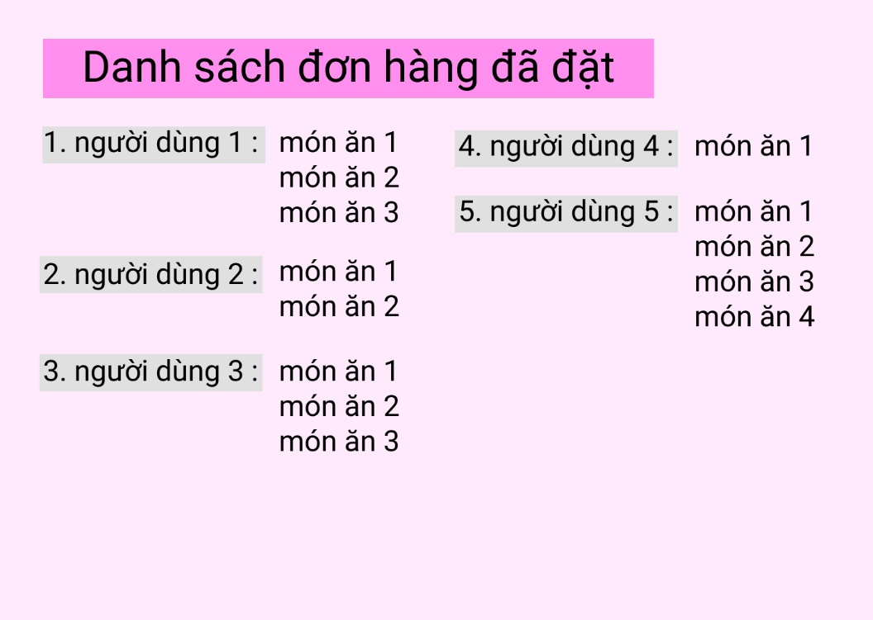

**2.2. Sequence Diagram:**

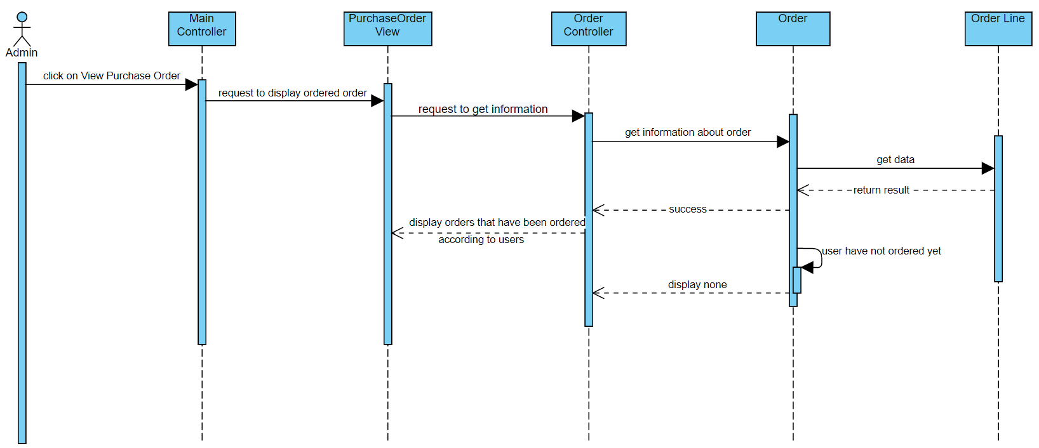

**2.3. Class Diagram:**

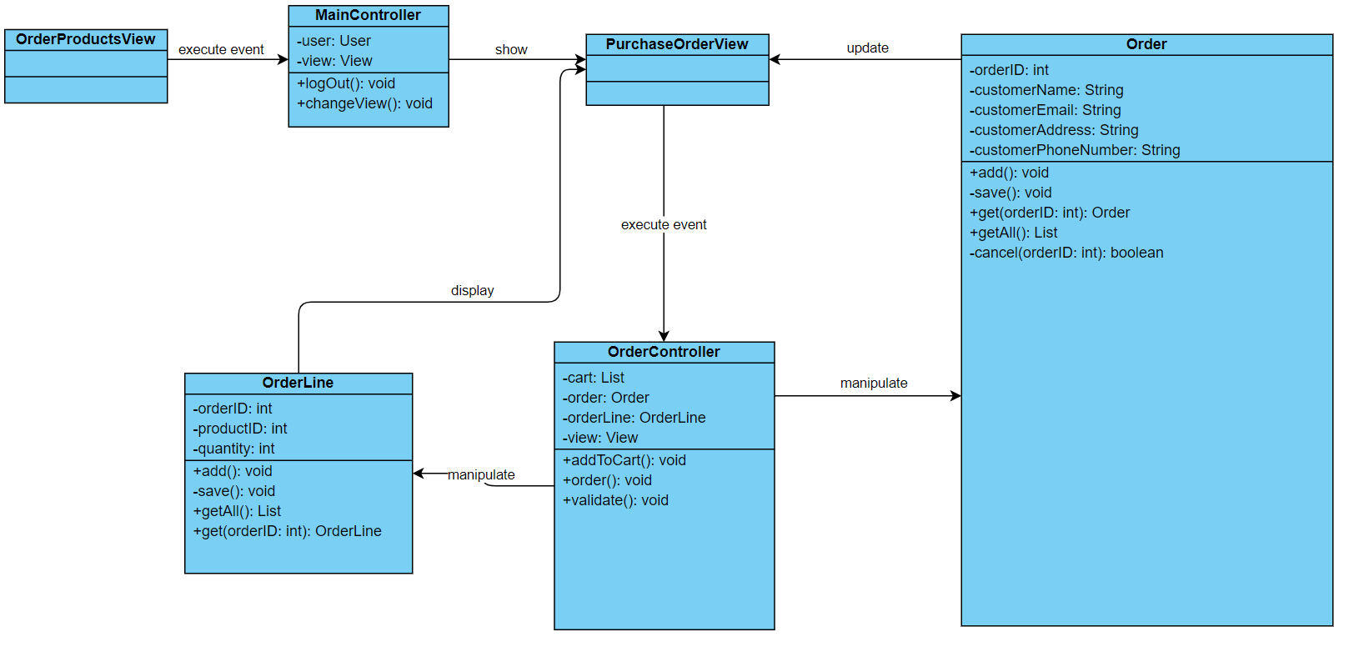

# Derived Requirements

None.